New Hire Roadmap

V.1 2025




ust.com

Copyright and Confidentiality

Copyright © 2024 by UST Global Inc. All rights reserved. This document is protected under the copyright laws of United States, India, and other countries as an unpublished work and contains information that shall not be reproduced, published, used in the preparation of derivative works, and/or distributed, in whole or in part, by the recipient for any purpose other than to evaluate this document. Further, all information contained herein is proprietary and confidential to UST Global Inc and may not be disclosed to any third party. Exceptions to this notice are permitted only with the express, written permission of UST Global Inc.
UST® is a registered service mark of UST Global Inc

UST
5 Polaris Way,
Aliso Viejo,
California 92656
United States

Contents

Introduction 4
Notes and Caveats 4
Contact Information 6
Helpful Links 7
Frequently Asked Questions 8
Ethics Point 9
Colors of UST 10
UStar 11

Introduction
Welcome to UST! We are thrilled to have you as part of our team. This document serves as your New Hire Playbook, providing you with a comprehensive guide to ensure a seamless onboarding experience. Our goal is to equip you with the necessary tools and knowledge to thrive in your new role and contribute meaningfully to the success of UST!
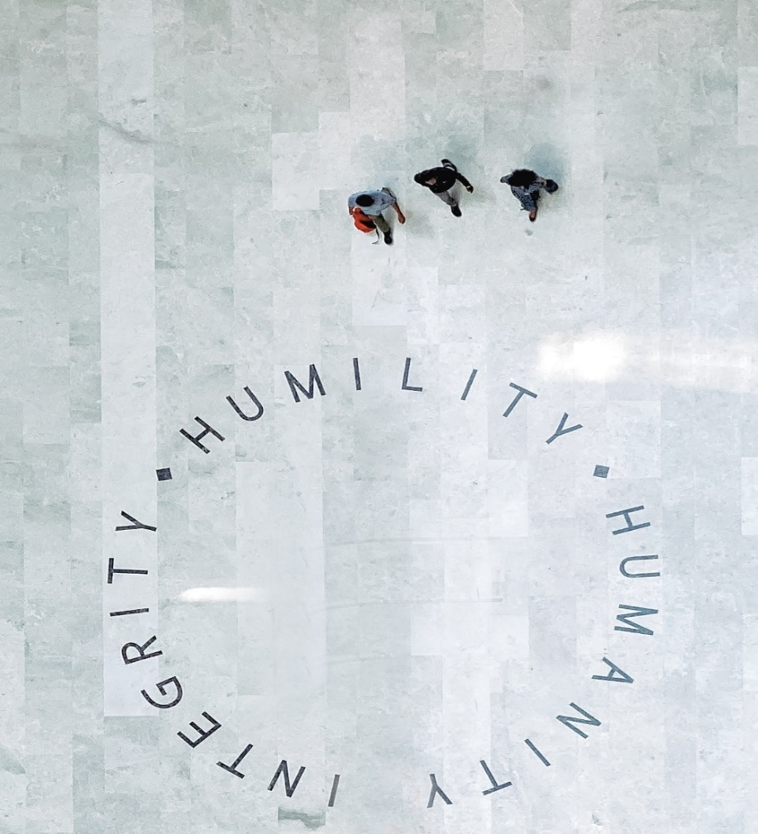

Notes and Caveats
This document is designed to provide general insight into expectations and resources a new hire. This is not designed to trump project-specific goals and educational needs, rather designed to supplement those goals to give our new associates the best possible set of tools and resources to ensure their success within UST. Exceptions to the above guidelines can and will be made on a case-by-case basis to ensure that all project-related work can be completed in a timely manner. However, all possible effort should be expended to adhere to this list of guidelines.
New Hire Checklist
- Set up company provided assets
- Collect ID Cards
- Access Timesheet Portal
- Attend New Hire Orientation (Mandatory GAMA learnings)
- Review helpful links
- Complete onboarding task in Workday
- Complete Day 1 survey

- Complete first-time login to UST systems
- Access UST email
- Set up Microsoft Teams
- Meet Reporting Manager
- Introduction to Workday and project expectations
- UAN creation (First time to Provident Fund)

- Review and Complete benefits enrollment
- Review and complete updation of bank account for salary
- Review and complete updation of UAN for Provident fund
- Complete 30-day survey

Contact Information
Team | Information | Contact Info
iSolve Helpdesk Team | Support for UST credentials and applications | ISHelpdesk@ust.com
iSolve Helpdesk Team | Support for UST credentials and applications | ISHelpDesk on Teams
iSolve Helpdesk Team | Support for UST credentials and applications | 0471-4045511
Payroll Team | Team to support employees in the US on different payroll related queries, workers compensation, and leaves of absence | HRPayroll@ust.com
HR Team | Front-end HR Support Team to support employees on HR queries | HRSolutions@ust.com
HR Team | India and APAC Onboarding and operation queries | HROnboarding@ust.com  HROps.APAC@ust.com
Benefits Team | Support for your employee insurance & benefits | Insurance@ust.com
REFM Team | Admin related support like, assets, seat, transportation, ID Card, facility management | Bengaluru - REFM.BLR@ust.com
REFM Team |  | Kochi - REFM.KOC@ust.com
REFM Team |  | Chennai - REFM.MAA@ust.com
REFM Team |  | Trivandrum - REFM.TVM@ust.com  Pune - WM.PNQ@UST.com
Finance Team | For all finance queries like investment declaration, tax filing, Form 16 etc. | Finance.payroll@ust.com
GAMA Helpdesk | Support for your learning/credential inquiries | GAMAHelpdesk@ust.com
Asset Team India | For all asset related queries and laptop readiness | AssetTeamIndia@ust.com
Reimbursement | Support for claiming reimbursement | EXPhelpdesk@ust.com
Timekeeping Systems | Support for your timekeeping inquiries | UandUSTSupport@ust.com

Helpful Links

Site | Link
Kubera – UST SharePoint | https://ustglobal.sharepoint.com/
Workday HRMS | Home - Workday (myworkday.com)
Workday Hub | Workday Hub - Home
UST Policy Portal | https://policymgmtsys.ust.com/home
Learning Hub | Dashboard | G. A. Menon Academy (GAMA) - UST Square
KnowB4 Training | https://training.knowbe4.com/ui/login
Career Velocity | https://ust-career-edge.edgenetworks.ai/#/pages/organization-hierarchy
iSolve | https://ustglobal.service-now.com/ust
Concur by SAP | https://us2.concursolutions.com/home
My Pay | https://mypayroll.myndsolution.com
Webmail | https://outlook.office.com
USource | https://usource.ripplehire.com/ripplehire/

Frequently Asked Questions
SYSTEMS & OTHER
- Where can I find UST’s SharePoint?
  - Kubera - Kubera (sharepoint.com)
- I am having issues with my UST laptop and or systems where do I go?
  - iSolve - iSolve Employee Center Homepage - iSolve
- I am facing issue or receiving error while trying to complete my first-time login. What should I do?
  - Please reach out to ishelpdesk@ust.com. Kindly ensure to share the screenshot of the error message while writing to them.
- When do we receive our ID Card?
  - Please reach out to respective REFM POC for update
- Is my asset ready and whom should I contact to get my laptop?
Location | POC | Contact no | Email ID
Trivandrum Technopark | Sreekumar Sukumaran | 9895571604 | Sreekumar.sukumaran@ust.com
Trivandrum Campus | Krishnapanicker Bhadrakumar | 9745604951 | Krishnapanicker.bhadrakumar@ust.com
Kochi | Harish Radhakrishnan | 9895762853 | Harish.radhakrishnan@ust.com
Kochi | Nithin Haridas | 8943004946 | Nithin.haridas@ust.com
Noida | Pankaj Kumar | 7838121600 | Pankaj.kumar3@ust.com
Pune | Palak Dewani | 9284004056 | Palak.dewani@ust.com
Bangalore | Sajindas Kappadan | 7022888279 | Sajindas.kappadan@ust.com
Bangalore | Navaneethamurali Selvraj | 9524417492 | Navaneethamurali.selvaraj@ust.com
Chennai | Lionel Cedric | 9500094403 | Lionel.cedric@ust.com
Hyderabad | Abraham Thekkekolath | 9895973950 | Abraham.t.thekekolath@ust.com
Hyderabad | Malyadri Kotapati | 7022596596 | Malyadri.kotapati@ust.com
Kolkata | Suman Ghosh | 9831191828 | Suman.ghosh1@ust.com
Coimbatore | Sooraj Panikkedath | 7907959011 | Sooraj.p@ust.com
- Where can I find leave policy information
  - Please click here

PAYROLL
- When will I receive the e-mail to update my bank account for salary?
  - Mail will be sent from hrsolutions@ust.com to official mail ID before your first payout
- I need bank POC details to contact for salary account creation.
  - Other location employees can reach out to any POC’s mentioned below
Location | HDFC​ | ICICI​ | Federal​ | SBI​
Bangalore​ | Chandan - 9113157003​ | Sylvian Monteiro - 9148871418​ | Romit T Komattu- 8483868230​ | Shibu CS – 9400271199​
Chennai​ | Anoop Joseph – 9381437047​ | Arumani Das – 9962825727​ | Santhosh M-9080399807​ | Mahavir 9916189980​
Chennai​ | Anoop Joseph – 9381437047​ | Arumani Das – 9962825727​ | Jacob George-7907112862​ | Mahavir 9916189980​
Hyderabad​ | Tirumaleshwar Rao- 9985990480​ | Ramamohan 9004443654​ | Pavan Kumar-9493801472​ | Shirish Sreehari 7673954731​
Kochi​ | Sa​ndhyav Vineesh - 9746379381 ​ | Sreenath R – 8129501287​ | Lakshmy - 9061031042 ​ | Divya 9446488891​
Trivandrum​ | Rahul S - 7012554108​ | Anish George - 8129310374​ | Binoj S Raj-9074752767​ | Renjith – 9188523950​

BENEFITS
- When will I have access to enroll in my benefits?
  - Enrollment e-mail will be sent to official e-mail ID within 14 days from date of joining
- Do I have to enroll in benefits?
  - Yes. Enrollment will not proceed automatically unless information is provided
- How can I enroll spouse, children, parents and in-laws into the insurance plan?
  - Click here for details

Ethics Point

EthicsPoint is a comprehensive reporting tool used by UST to assist management and employees to address workplace concerns and complaints including, but not limited to, fraud, abuse, harassment, discrimination and other misconduct in the workplace. UST is committed to providing a safe and healthy workplace for all employees and this platform is a crucial part of that commitment.
Click here

Why do we need a system like EthicsPoint?
- We believe that our employees are our most important asset. By creating open channels of communication, we can promote a positive work environment and maximize productivity.
- We are committed to the highest ethical standards and have therefore chosen to have an anonymous reporting vehicle to address unethical business practices.
- An effective reporting system will augment our other efforts to foster a culture of integrity and ethical decision-making.

If you have a question concerning a topic other than ethics and compliance, please contact the appropriate department listed below.
Governance, Risk and Compliance (GRC) | GRC@ust.com
HR Solutions | HRSolutions@ust.com
IS Helpdesk | ISHelpdesk@ust.com

Colors of UST
The Colors of UST are volunteer-driven teams that empower our employees to improve both within our company and in the communities, we call home. Each Color initiative is designed to enable employees to partner on sustainable goals. Before enrolling, employees will pick the color or colors that best suit your passion and skill set. Join us to transcend boundaries, so we can collectively make an impact that's truly boundless!

 | Global Branding  The Color gold initiative empowers UST employees worldwide to champion the UST brand. The global brand team ambassadors tell the UST story across the globe, sharing our 'special sauce' while making sure that we communicate our strong sense of purpose.
 | Growth  At UST, personal and professional development opportunities are a part of our individual and combined success. The growth team develops programs to help employees hone their skills and grow individually.
 | Innovation  These creators and problem solvers partner with UST's innovation initiatives to run hackathons, design thinking workshops, and seminars that help UST constantly push technology boundaries for our clients.
 | Digital Organization  The digital organization team improves employee experience by transforming UST's internal processes with digital automation initiatives.
 | People  The people team develops health and wellness programs, family events, and opportunities for fun to improve the employee experience, ensuring that UST provides a positive work environment for all.
 | Quality and Speed  By optimizing processes and identifying reusable assets, the quality and speed team internally improves UST's work quality and efficiency.
 | Community Relations  The rose team focuses on strengthening communities, empowering community members, and building collectively for boundless impact through global volunteering initiatives.

Learn More about the Colors of UST program: Colors of UST (sharepoint.com)

USTAR
UST is committed to fostering a positive and appreciative workplace culture. With our innovative recognition system Ustar you have the power to recognize and celebrate your colleagues’ outstanding contributions!
Every time you give a Ustar to a fellow team member, you not only acknowledge their hard work but also contribute to their valuable points. As you collect these points, you unlock an array of rewards ranging from Fashion, Electronics, Gift Cards/Vouchers, Home Goods, Health and Beauty, plus so much more!
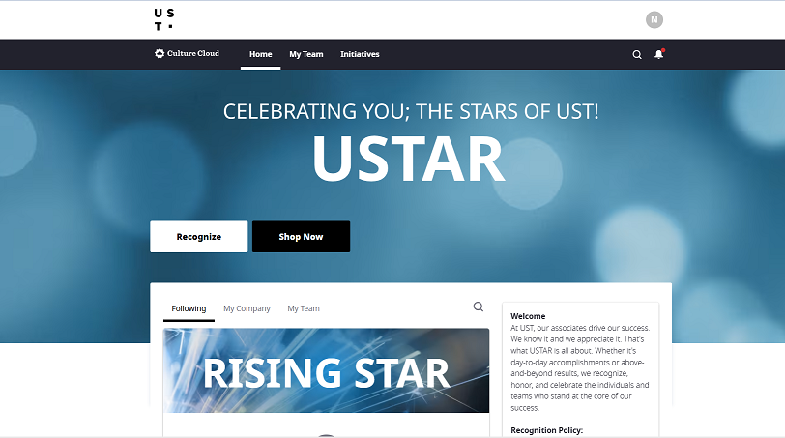


Copyright © 2024 UST Global Inc
ust.com

